Vehicle Details:
No. 5174 Toyota Corolla - burned

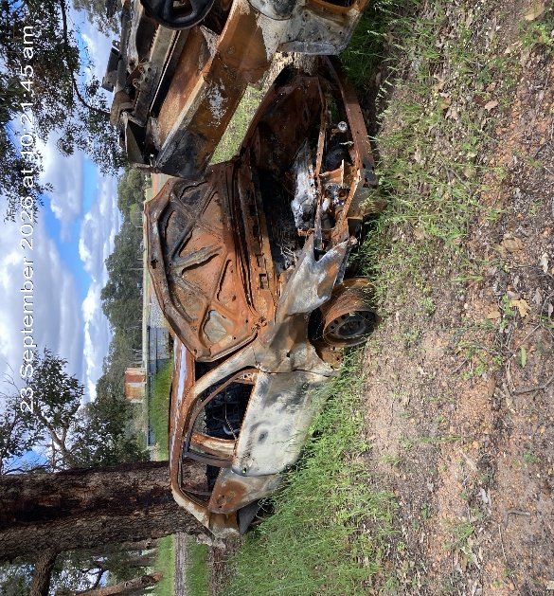

No. 5173 Subaru Outback - burned
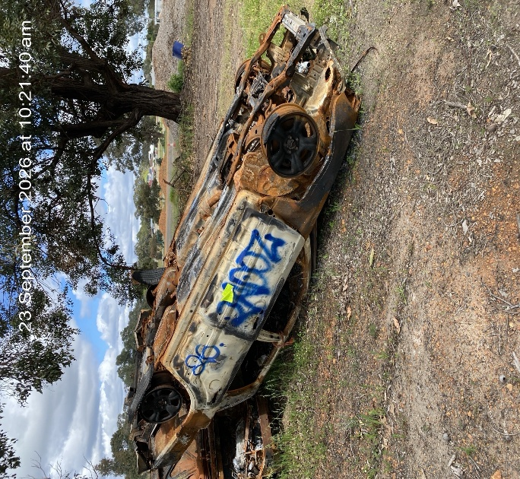

No. 5172 Kia Carnival
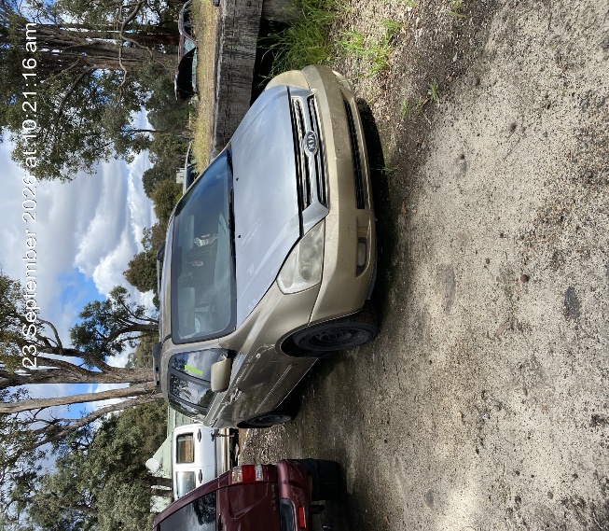

No. 5171 Holden Rodeo
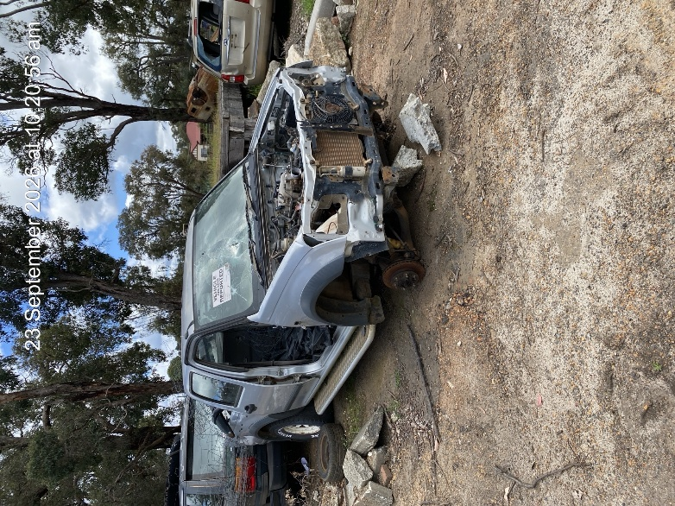

No. 5170 Land Rover Range Rover

